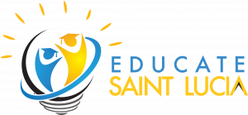
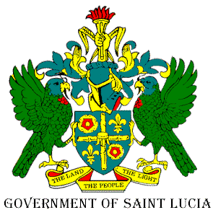
Reading Month, 2022
Theme: All Hands on Deck for Literacy
Tagline: Join the Reading Crew in 2022!
Hashtag: #allhands758

Concept Note
In 2021, United Nations Educational, Scientific and Cultural Organization (UNESCO) commemorated International Literacy Day (IDL) under the theme “Literacy for a human-centered recovery: Narrowing the digital divide”. It is undeniable that this pandemic provides us with seeds of opportunity to adopt a human-centered approach to narrowing the digital divide and it is essential that we seize these opportunities. To do so, we need a collective commitment to close learning gaps and strive for a more inclusive, equitable and sustainable educational experience for all learners. This outlook is the basis for the recent OECS Declaration on Education. We are given a unique opportunity to rethink and redirect, and it is imperative that we collaborate at all levels, both within the education system and outside of the system. Our collaborators must include students, parents, community/civil society groups, non-governmental organizations and commercial entities.
This collaboration is necessary because we understand that education requires the input and effort of all. Effective and lasting learning cannot happen only within the physical school plant. In the last few months, for instance, with virtual schooling, parents took on a greater supervisory role, while community groups and business organizations donated funds and resources to improve teachers’ and students’ access to technology tools. However, in addition to tangible contributions, the expertise of these community members is equally, or even more, valuable in the instruction of learners.
Therefore, the theme for Reading Month 2022 is: “All Hands on Deck for Literacy”. We invite all to contribute to literacy in Saint Lucia. This can be done in several ways:
- Developing personal and family literacy habits, including reading and talking about books, writing, and creating and sharing positive content
- Sharing reading material with children and youth
- Accepting and accommodating differing learner skill levels
- Increasing community participation in school life
- Contributing resources (financial and human) to student learning experiences
- Using our culture and environment as the basis for learning
We encourage everyone to participate in and support the Ministry of Education’s Reading Month activities this year. Contact a school and find ways that you and your organization can contribute sustainably to student learning outcomes.
Happy Reading Month, 2022!

